Memmert presents the current HCP generation

New humidity chamber specially designed for 85/85 tests

Schwabach, April 2018

From now on, all Memmert HCP humidity chambers are available with the TwinDISPLAY convenience features as standard. A compact 56 litre benchtop model complements the humidity chamber range, first presented at Control 2018 in Stuttgart.

Extensive comfort functions
This high-quality climate chamber is an economical and almost maintenance-free alternative to appliances with active cooling, especially for applications above room temperature such as accelerated service life tests and 85/85 tests. The ControlCOCKPIT touch screen control unit is the HCP's control centre, where all parameters can be set in three quick steps. Status messages as well as time and alarm messages are also displayed simultaneously. The TwinDISPLAY convenience features also allow communication via modern interfaces and intuitive and simple programming via the control and protocol software AtmoCONTROL. Specially adapted functions such as battery-buffered operating display, SetpointWAIT function for temperature-dependent process runtime, alarm messages via e-mail or SMS and standard feed-throughs on the rear panel support reliable and precise testing processes.

Active humidity control minimises condensation
Like all Memmert climate chambers that operate in the positive temperature range, the humidity chamber HCP also has active humidity control. It guarantees reliable homogeneity of temperature and humidity as well as short recovery times after opening the door. In combination with heating on all six sides, including heated inner glass door, it minimises vaporisation in the interior and thus the risk of condensed water dripping onto the test object.

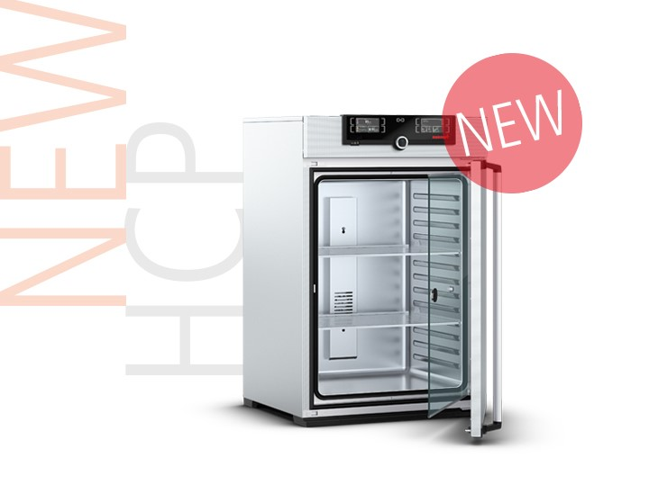

(Illustration: Memmert humidity chamber HCP)

Responsible for content:
Memmert GmbH & Co. KG
Jenny Weisler
Postfach/PO Box 1720
D-91107 Schwabach, Germany
Tel: +49 (0) 91 22/925-199
Fax:+49 (0) 9122 / 14585
e-mail: jweisler@memmert.com

