Memmert switches to climate-friendly refrigerant

Environmental test chambers CTC and TTC now with climate-friendly refrigerant R449A

Schwabach, April 2018.

Memmert is now converting the climate test chamber CTC and the temperature test chamber TTC to the refrigerant R449A. The operation of all appliances is thus ensured beyond 31/12/2019.

EU regulation on fluorinated greenhouse gases imposes conversion
The F-Gas Regulation aims to reduce emissions from the industrial sector in the EU by 70 percent by 2030 compared to 1990. The aim is to reduce emissions of fluorinated greenhouse gases (F-gases) by 70 million tonnes CO₂-equivalent to 35 million tonnes CO₂-equivalent by 2030. To this end, the utilisation of currently used fluorocarbons (HFCs) with a Global Warming Potential (GWP) of more than 2500 will be phased out. For this reason, the refrigerant R404A frequently used in test cabinets with refrigeration systems is only permitted without restriction until 31 December 2019.

In order to give customers the certainty that their CTC/TTC environmental test chambers can also be operated beyond this date, Memmert has reacted early by switching to the refrigerant R449A. Existing appliances can also be converted to the new refrigerant in the "drop-in" or "retrofit" process, depending on the application. A leakage test can be performed as part of this.

The new refrigerant is significantly more climate-friendly
To compare the contribution of substances to the warming of layers of air near the ground and thus to the greenhouse effect, the GWP value in relation to carbon dioxide (CO₂) is used with the GWP value of 1. According to this formula, one kilogram of the refrigerant R404A contributes 3922 times as much to the greenhouse effect within the first 100 years of its release as one kilogram of CO₂. The GWP value of the new refrigerant R449A is around 65 % lower (GWP = 1397).

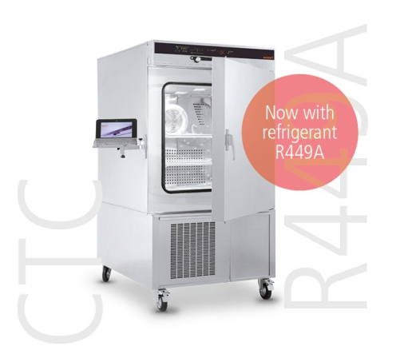

Memmert environmental test chambers CTC/TTC now with refrigerant R449A

Responsible for content:
Memmert GmbH & Co. KG
Jenny Weisler
Postfach/PO Box 1720
D-91107 Schwabach, Germany
Tel: +49 (0) 91 22/925-199
Fax:+49 (0) 9122 / 14585
e-mail: jweisler@memmert.com

