Memmert switches to climate-friendly refrigerant

Compressor-cooled climate chambers and incubators ICHeco/ICPeco now CO₂-cooled

Schwabach, May 2018.

Memmert introduces two temperature control appliances with climate-friendly CO₂ as the refrigerant (R744) for ACHEMA 2018. The ICHeco climate chamber and the ICPeco compressor-cooled incubator are not only more environmentally friendly, but also more efficient than appliances cooled with fluorinated greenhouse gases.

CO₂ refrigerant is climate-friendly
With the gradual phasing out of synthetic refrigerants, Memmert is expanding its range of environmentally-friendly temperature control appliances. With the constant climate chamber HPP and the cooled incubator IPP, Memmert has already been offering Peltier-cooled, environmentally friendly temperature control appliances without a refrigeration compressor for many years.

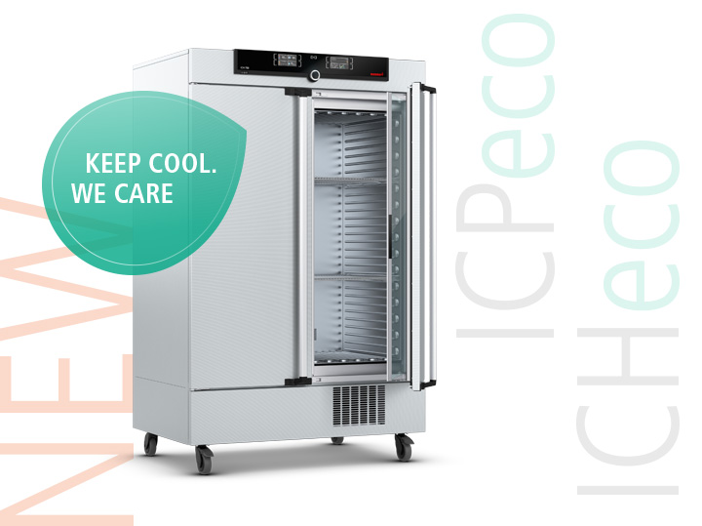

Memmert climate chamber ICHeco/compressor-cooled incubator ICPeco now with natural refrigerant CO₂ (R744)

The GWP value (Global Warming Potential) is used to compare the effects of substances on the warming of air layers near the ground and thus on the greenhouse effect. The refrigerant used with immediate effect in Memmert ICHeco/ICPeco appliances with the abbreviation R744 and the chemical molecular formula CO₂ has a GWP value of 1 and is therefore almost climate-neutral. By contrast, the refrigerant R134a, with a GWP of 1430, contributes 1430 times as much to the greenhouse effect in the first 100 years after its release. In addition, R744 does not contain chlorine, is neither flammable nor toxic, does not cause ozone depletion in the atmosphere and does not need to be disposed of or recycled. This is a by-product of industrial processes, which is why far less energy is used for its production than for synthetic, fluorinated refrigerants.

F-Gas regulation provides incentives for conversion
The European Union's new F-gas regulation aims to reduce emissions of fluorinated greenhouse gases by around 90 % by 2050 compared with 1990. Measures include gradual reductions in volumes and bans on placing it on the market. For example, new commercial refrigerators with a GWP greater than 150 may no longer be sold from 1 January 2022. "Memmert reacted early for several reasons," explains Stefan Kaufmann, Head of Development Department at Memmert. "On the one hand, our new eco appliances have a positive impact on our customers' environmental balance sheet, and on the other hand, they score points with improved cooling capacity."

Both appliances also feature the proven Memmert air jacket temperature control system, via which heat is quickly introduced into the interior over a large area via four sides. The hermetically sealed working area offers numerous advantages: no dehumidification in the interior and thus no dehydration of sensitive samples and no icing over of the cooling unit. In addition, the climate chamber ICH does not consume any water after reaching the setpoints as long as the door is not opened.

Responsible for content:
Memmert GmbH & Co. KG
Jenny Weisler
Postfach / PO Box 1720
D-91107 Schwabach, Germany
Tel: +49 (0) 91 22/925-199
Fax: +49 (0) 9122 / 14585
Email: jweisler@memmert.com

